LAB PROGRAMS:

**PROGRAM1:** **Shell script to find if the given year is leap or not**

CODE:

#!/bin/sh

echo "Enter the year "

read year

if [ $((year%400)) -eq 0 ]

then

echo "It's a leap year"

elif [ $((year%4)) -eq 0 ]

then

if [ $((year%100)) -eq 0 ]

then

echo "It's a non leap year"

else

echo "It's a leap year "

fi

else

echo "It's a non leap year "

fi

OUTPUT:

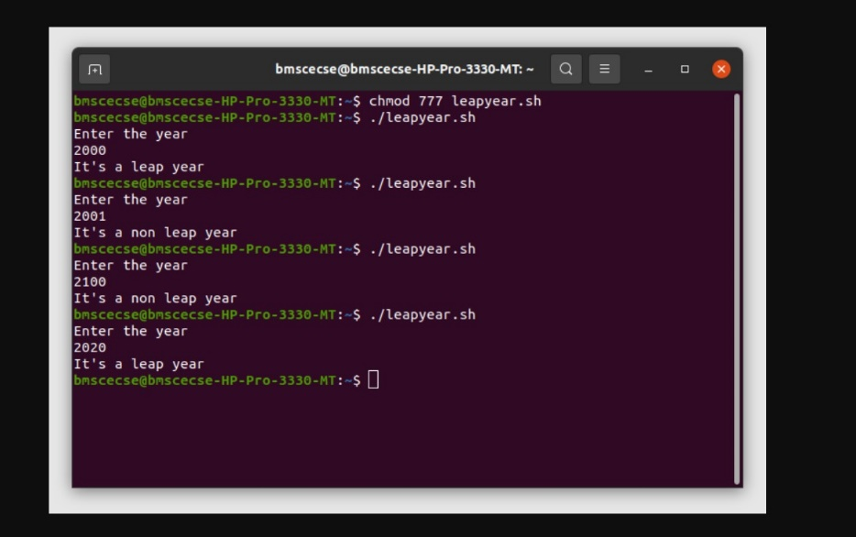

**PROGRAM2: Shell script to find the area of a circle**

CODE:

#!/bin/sh

echo "Enter the radius of the circle "

read r

pi=3.142

area=`echo $pi\$r\$r|bc`

echo "The area of the circle is : $area"

OUTPUT:

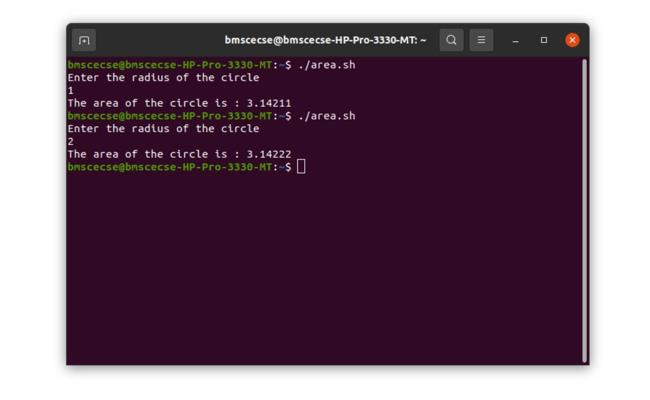

**PROGRAM3:** **Shell script to check whether the number is zero/ positive/ negative**

CODE:

#!/bin/sh

echo "Enter the number "

read num

if [ $num -eq 0 ]

then

echo "The number is zero "

elif [ $num -lt 0 ]

then

echo "The number is negative "

else

echo "The number is positive"

fi

OUTPUT:

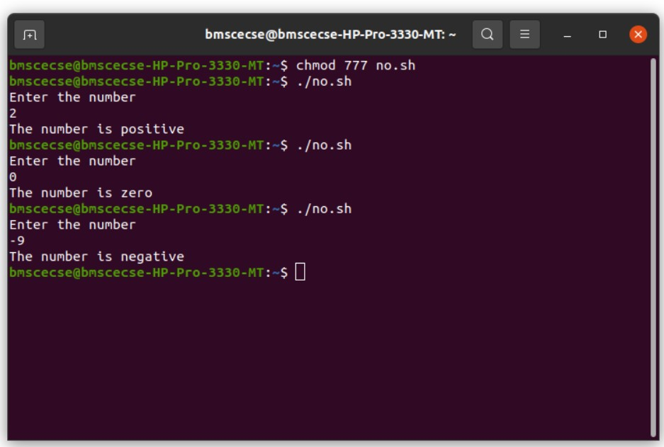

**PROGRAM4:** **Shell script to find the biggest of three numbers**

CODE:

#!/bin/sh

echo "Enter the first no "

read f

echo "Enter the second no"

read s

echo "Enter the third no "

read t

if [ $f -gt $s -a $f -gt $t ]

then

echo "The first no is the biggest "

elif [ $s -gt $f -a $s -gt $t ]

then

echo "The second no is the biggest "

else

echo "The third no is biggest"

fi

OUTPUT:

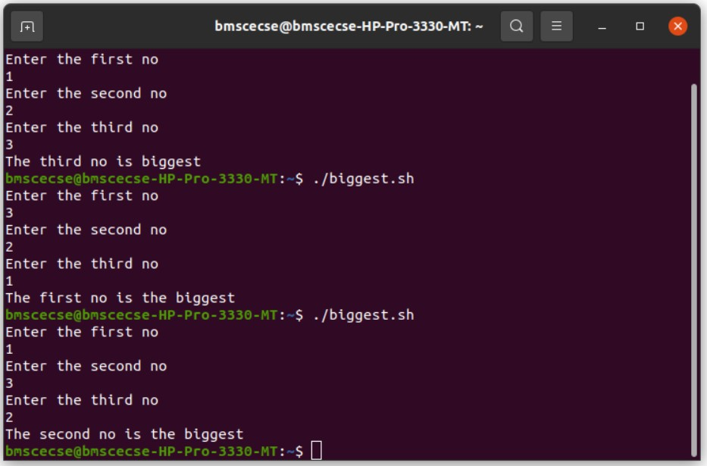

**PROGRAM5:** **Shell script to find the factorial of a number**

CODE:

#!/bin/bash

echo "Enter the no "

read no

st=1

fact=1

for (( c=$st; c<=$no; c++))

do

fact=`expr $c\*$fact|bc`

done

echo "factorial is "$fact

OUTPUT:

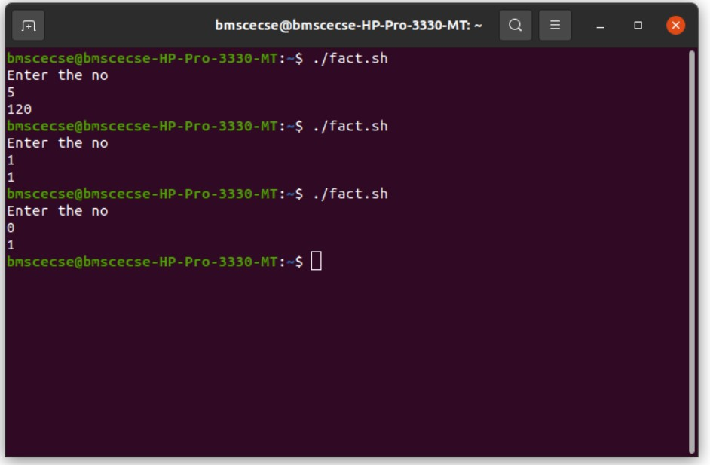

**PROGRAM6:** **Shell script to compute the gross salary of an employee**

CODE:

#!/bin/sh

echo "Enter the basic Sallary"

read basic

da=`expr $basic\*10/100|bc`

hra=`expr $basic\*20/100|bc`

gross_sal=`expr $basic+$da+$hra|bc`

echo "The gross salaery is "$gross_sal

OUTPUT:  
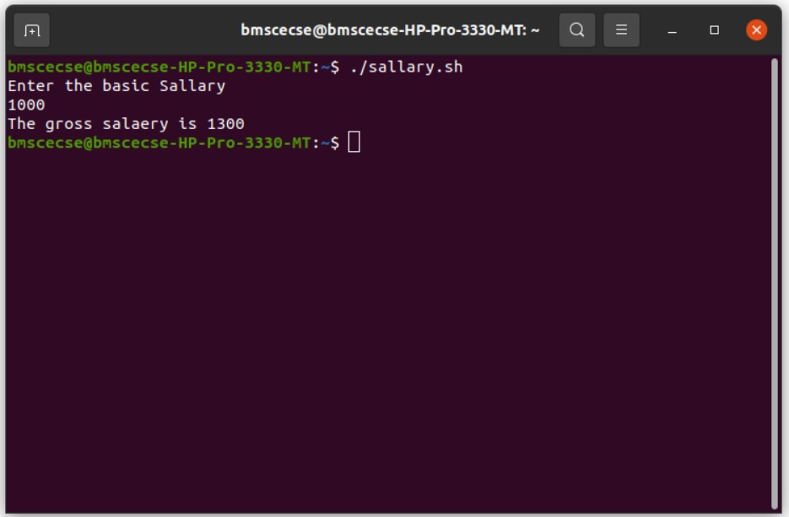

**PROGRAM7: Shell script to convert the temperature Fahrenheit to Celsius**

CODE:

#!/bin/sh

echo "Enter the temperature in Fahrenheit :"

read temp

var=32

f=`expr $temp-$var|bc`

s=`expr $f\*5|bc`

echo "The temperature in celcuis is "

echo "scale=2; $s/9"|bc

OUTPUT:

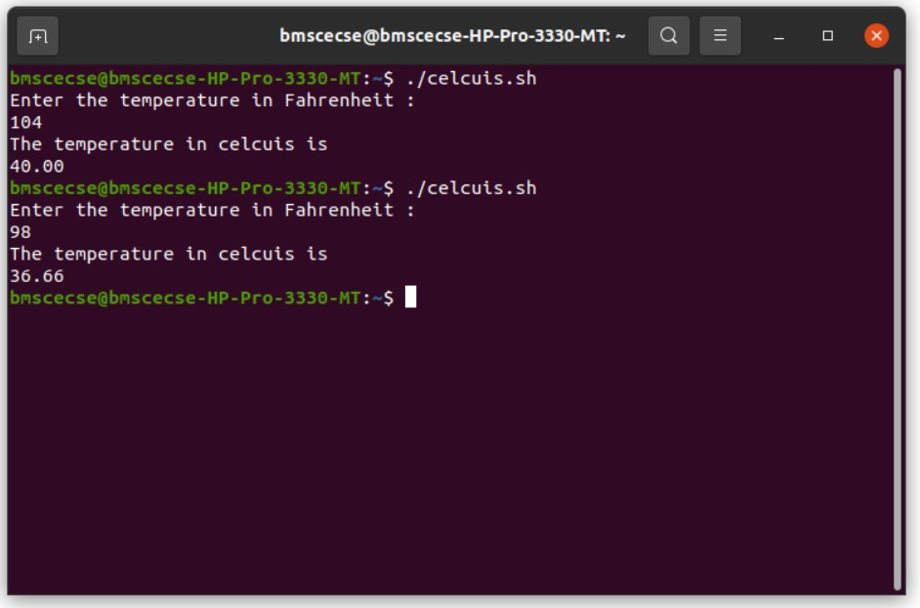

**PROGRAM8: Shell script to perform arithmetic operations on given two numbers**

CODE:

#!/bin/sh

echo "Enter first no"

read f

echo "Enter second no"

read s

echo "The sum is:"

echo "$f+$s"|bc

echo "The difference is :"

echo "$f-$s"|bc

echo "the product is :"

echo "$f*$s"|bc

echo "the division is :"

echo "scale=2; $f/$s"|bc

OUTPUT:

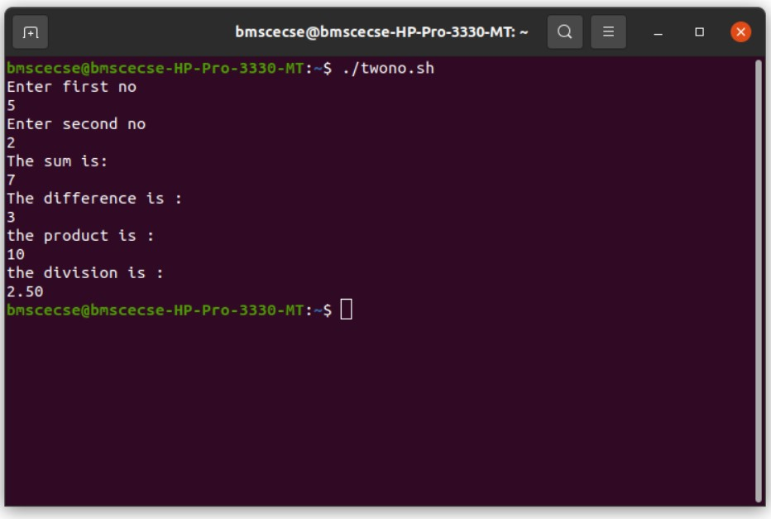

**PROGRAM9: Shell script to find the sum of even numbers upto n**

CODE:

#!/bin/bash

echo "enter the value of n:"

read n

sum=0

for ((c=0; c<=$n; c=c+2))

do

sum=`expr $sum+$c|bc`

done

echo "sum of even no upto $n is $sum"

OUTPUT:

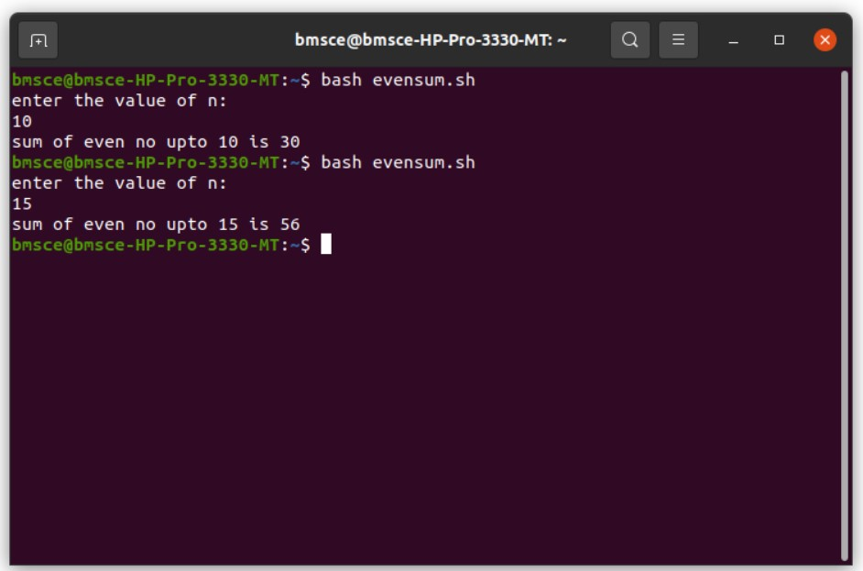

**PROGRAM10: Shell script to print the combinations of numbers 123**

CODE:

#!/bin/sh

for i in 1 2 3

do

for j in 1 2 3

do

for k in 1 2 3

do

echo $i $j $k

done

done

done

OUTPUT:

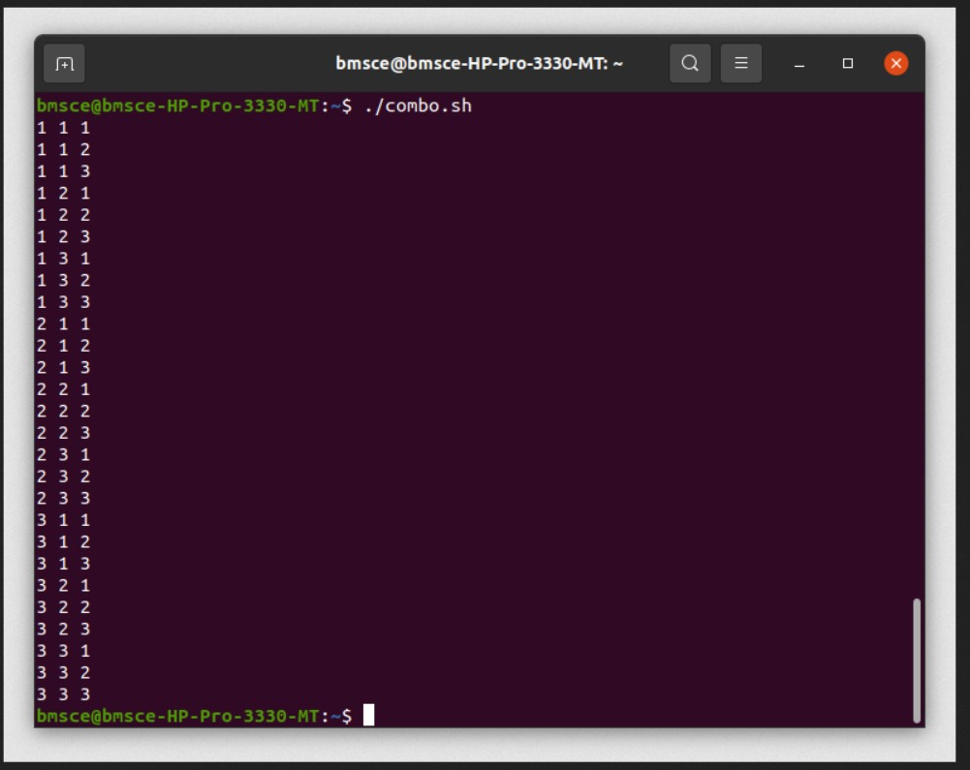

**PROGRAM11: Shell script to find the power of a number**

CODE:

#!/bin/bash

echo "enter the base value"

read b

echo "enter the value of power"

read p

res=1

for ((c=1; c<=$p; c++))

do

res=`echo "scale=3; $b*$res"|bc`

done

echo $res

OUTPUT:

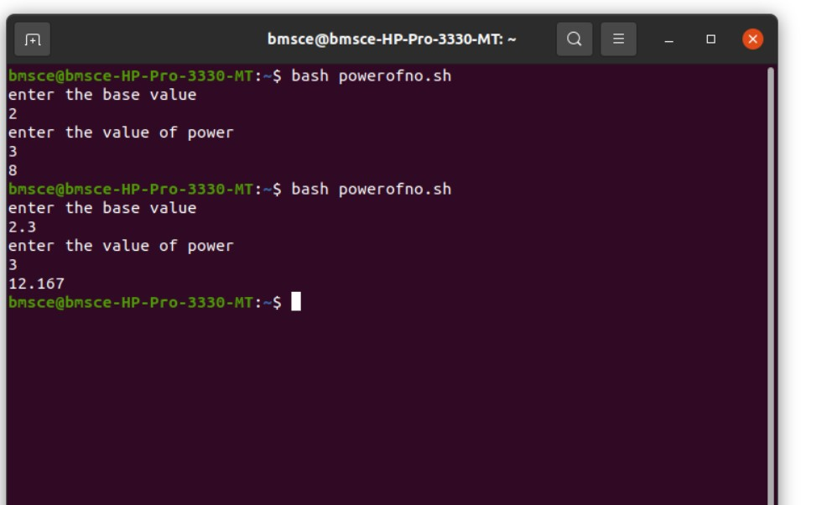

**PROGRAM12:** **Shell script to find the sum of n natural numbers**

CODE:

#!/bin/bash

echo "enter the value of n:"

read n

sum=0

for ((c=0; c<=$n; c++))

do

sum=`expr $sum+$c|bc`

done

echo "sum of $n natural numbers is $sum"

OUTPUT:

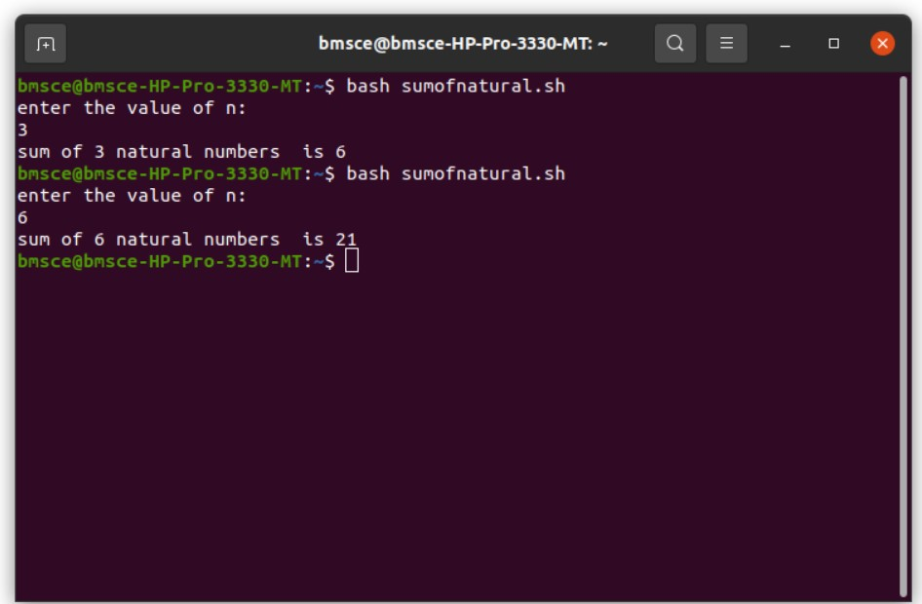

**PROGRAM13: Shell script to display the pass class of a student**

CODE:

#!/bin/sh

pass=0

fail=0

i=1

while [ $i -le 6 ]

do

echo "Enter the cie and see marks(out of 50 for see) of the sub$i "

read cie see

total=`expr $cie+$see|bc`

case $total in

100) echo "S grade "

pass=$((pass+1)) ;;

9[0-9]) echo "S grade "

pass=$((pass+1)) ;;

8[0-9]) echo "A grade "

pass=$((pass+1)) ;;

7[0-9]) echo "B grade "

pass=$((pass+1)) ;;

6[0-9]) echo "C grade "

pass=$((pass+1)) ;;

5[0-9]) echo "D grade "

pass=$((pass+1)) ;;

4[0-9]) echo "E grade "

pass=$((pass+1)) ;;

[0123][0-9]) echo "F grade "

fail=$((fail+1)) ;;

*)echo "error in input"

esac

i=$((i+1))

done

echo -e "no of sub passed : $pass\nno of subjects failed $fail\n"

OUTPUT:

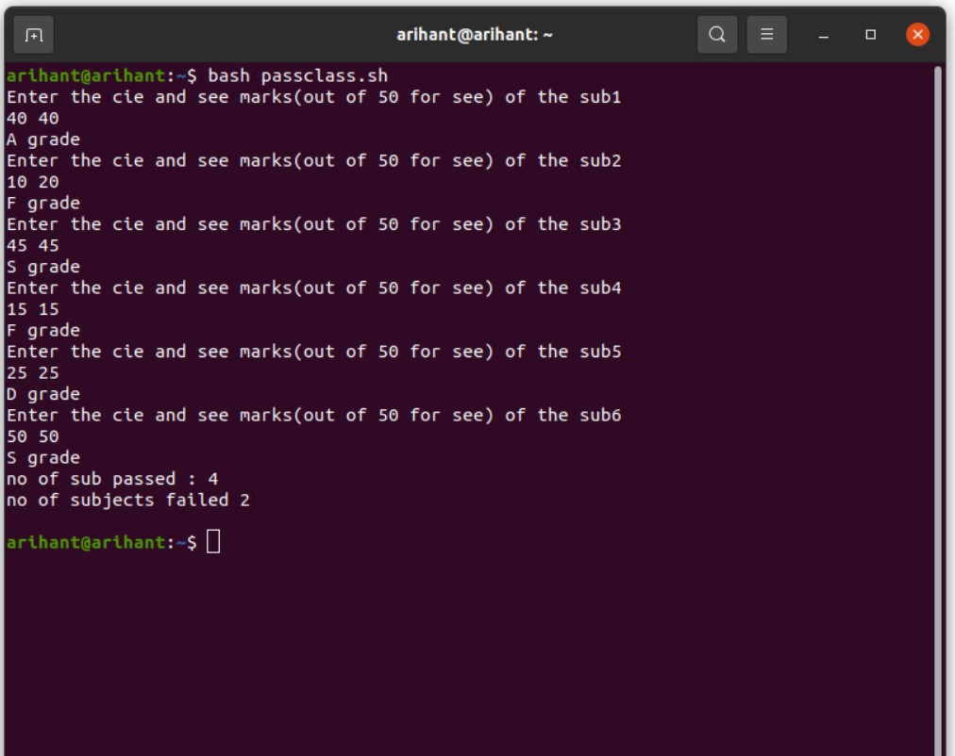

**PROGRAM14: Shell script to find the Fibonacci series up to n**

CODE:

#!/bin/sh

echo "Enter the no"

read no

m=0

n=1

while [ $no -gt 0 ]

do

echo -e "$m \c"

temp=$m

m=$((m+$n))

n=$temp

no=$((no-1))

done

OUTPUT:

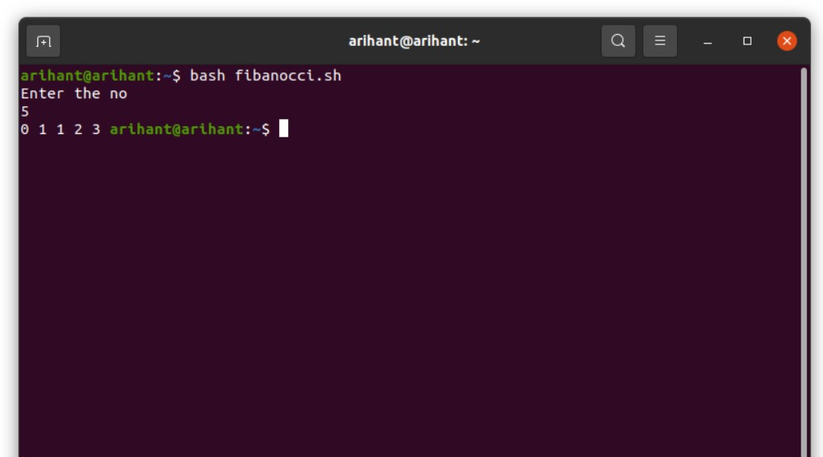

**PROGRAM15: Shell script to count the number of vowels of a string**

CODE:

#!/bin/sh

echo "Enter the string "

read str

count=0

len=`expr length $str`

while [ $len -gt 0 ]

do

ch=`expr $str | cut -c $len`

case $ch in

[aeiouAEIOU]) count=$((count+1)) ;;

esac

len=$((len-1))

done

echo "the vowels in string are $count "

OUTPUT:

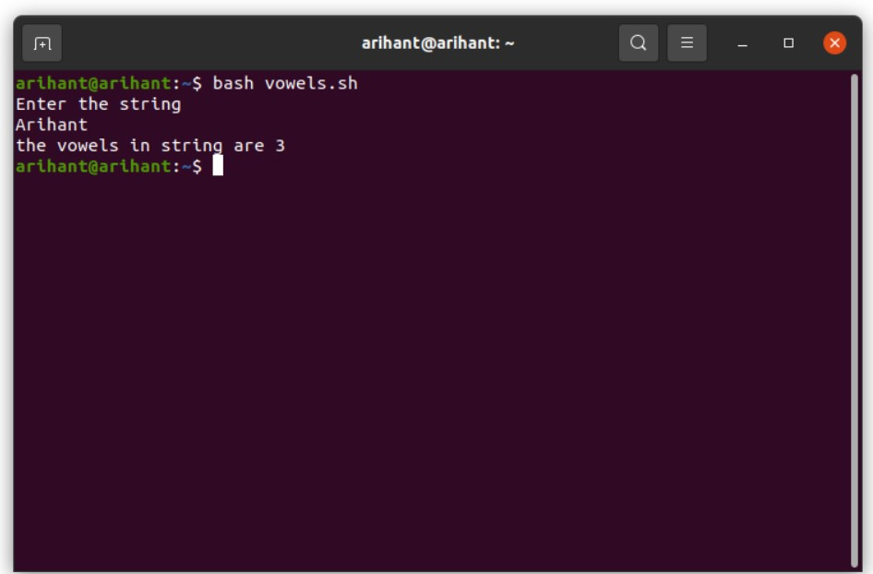

**PROGRAM16: Shell script to check number of lines, words, characters in a file**

CODE:

#!/bin/sh

echo "Enter the filename "

read fname

l=`wc -l < $fname`

w=`wc -w < $fname`

c=`wc -m < $fname`

echo -e "no of lines $l\nno of words $w\nno of characters $c\n"

OUTPUT:

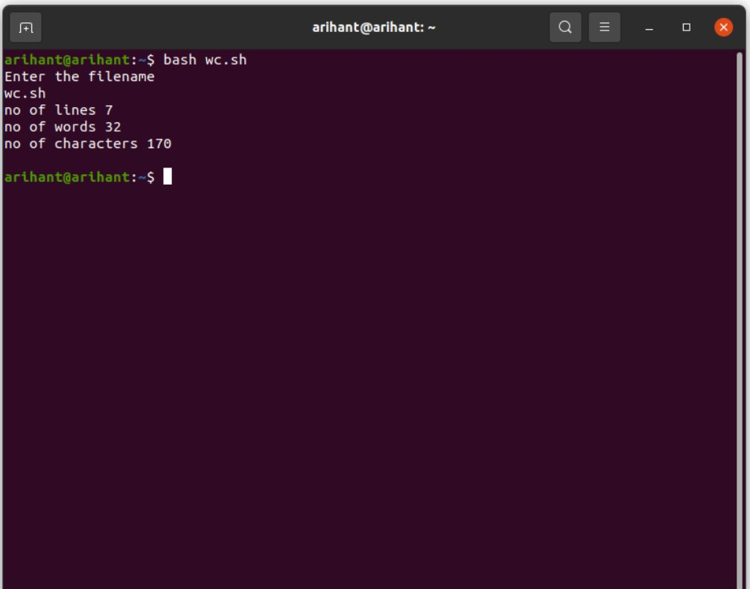

**PROGRAM17: Write a C/C++ program to that outputs the contents of its Environment list**

CODE:

#include <stdio.h>

int main(int argc, char* argv[ ])

{

int i;

char **ptr;

extern char **environ;

for( ptr = environ; *ptr != 0; ptr++ ) /*echo all env strings*/

printf("%s\n", *ptr);

return 0;

}

OUTPUT:

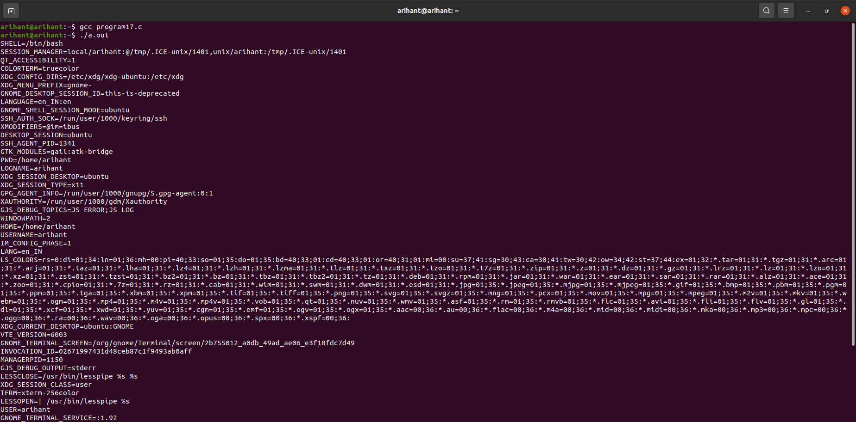

**PROGRAM18: Write a C/C++ program to emulate the unix ln command**

CODE:

#include<stdio.h>

#include<sys/types.h>

#include<unistd.h>

#include<string.h>

int main(int argc, char * argv[])

{

if(argc < 3 || argc > 4 || (argc == 4 && strcmp(argv[1],"-s")))

{

printf("Usage: ./a.out [-s] <org_file> <new_link>\n");

return 1;

}

if(argc == 4)

{

if((symlink(argv[2], argv[3])) == -1)

printf("Cannot create symbolic link\n");

else

printf("Symbolic link created\n");

}

else

{

if((link(argv[1], argv[2])) == -1)

printf("Cannot create hard link\n");

else

printf("Hard link created\n");

}

return 0;

}

OUTPUT: 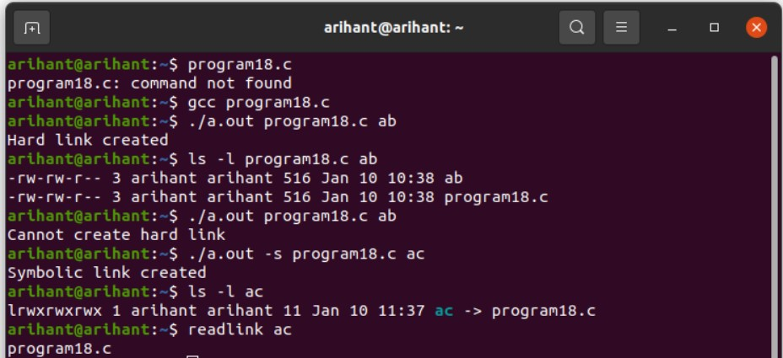

**PROGRAM19:** **Write a C/C++ POSIX compliant program that prints the POSIX defined**

**configuration options supported on any given system using feature test macros.**

CODE:

#define _POSIX_SOURCE

#define _POSIX_C_SOURCE 199309L

#include<stdio.h>

#include<unistd.h>

int main()

{

#ifdef _POSIX_JOB_CONTROL

printf("System supports job control\n");

#else

printf("System does not support job control \n");

#endif

#ifdef _POSIX_SAVED_IDS

printf("System supports saved set-UID and saved set-GID\n");

#else

printf("System does not support saved set-UID and saved set-GID \n");

#endif

#ifdef _POSIX_CHOWN_RESTRICTED

printf("chown_restricted option is %d\n", _POSIX_CHOWN_RESTRICTED);

#else

printf("System does not support chown_restricted option \n");

#endif

#ifdef _POSIX_NO_TRUNC

printf("Pathname trunc option is %d\n",_POSIX_NO_TRUNC);

#else

printf("System does not support system-wide pathname trunc option \n");

#endif

#ifdef _POSIX_VDISABLE

printf("Disable character for terminal files is %d\n",_POSIX_VDISABLE);

#else

printf("System does not support _POSIX_VDISABLE \n");

#endif

return 0;

}

OUTPUT:

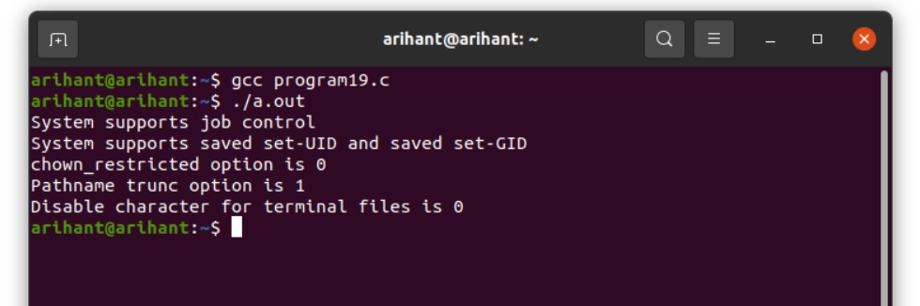

**PROGRAM20:** **Write a C/C++ program which demonstrates interprocess communication between a reader process and a writer process. Use mkfifo, open, read, write and close APIs in**

**your program.**

CODE:

#include<sys/types.h>

#include<unistd.h>

#include<fcntl.h>

#include<sys/stat.h>

#include<string.h>

#include<errno.h>

#include<stdio.h>

int main(int argc, char* argv[])

{

int fd;

char buf[256];

if(argc != 2 && argc != 3)

{

printf("USAGE %s <file> [<arg>]\n",argv[0]);

return 0;

}

mkfifo(argv[1],S_IFIFO | S_IRWXU | S_IRWXG | S_IRWXO );

if(argc == 2) //reader process

{

fd = open(argv[1], O_RDONLY|O_NONBLOCK);

while(read(fd, buf, sizeof(buf)) > 0)

printf("%s",buf);

}

else

{

fd = open(argv[1], O_WRONLY);

write(fd,argv[2],strlen(argv[2]));

}

close(fd);

}

OUTPUT:

